**Digestive System**

**(and Working Scientifically)**

**Content**

Structure and function of the digestive system related to:

* mechanical digestion including teeth, bile and the processes of peristalsis and churning
* chemical digestion of carbohydrates, lipids and proteins including the enzymes and the associated glands
* absorption of nutrients
* role of the liver in processing and storing nutrients
* elimination

Basic chemistry of organic molecules

Effects of lifestyle choices on the digestive system:

* vitamin and mineral deficiency; constipation and diarrhoea; bowel cancer

Scientific method

* hypotheses
* variables – independent, dependent, control
* presenting data in graphs and tables
* placebos, experimental errors

**Questions from Text**

Chapter 7 Chapter 1

Review Questions: 5-13 Review Questions: 2, 4-10

Apply Your Knowledge: 3-5 Apply Your Knowledge: 5 & 6

Chapter 2

Review Questions: 1-10

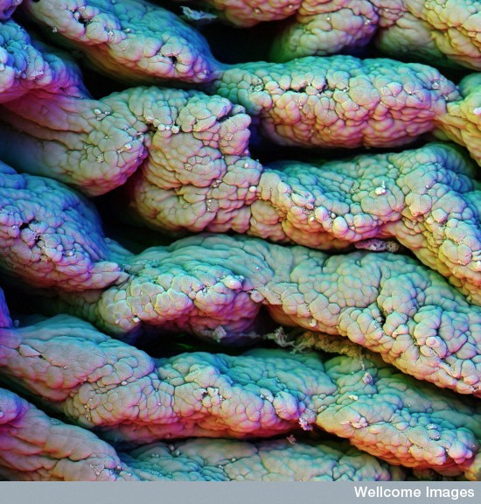Apply Your Knowledge: 1 & 2

Folds in the intestinal wall as viewed with an electron microscope

(http://images.wellcome.ac.uk/)